Surgical anatomy of duodenum

Parts of duodenum
- Superior / First part
- Descending / Second part
- Horizontal / Third part
- Ascending / Fourth part

Parts of duodenum

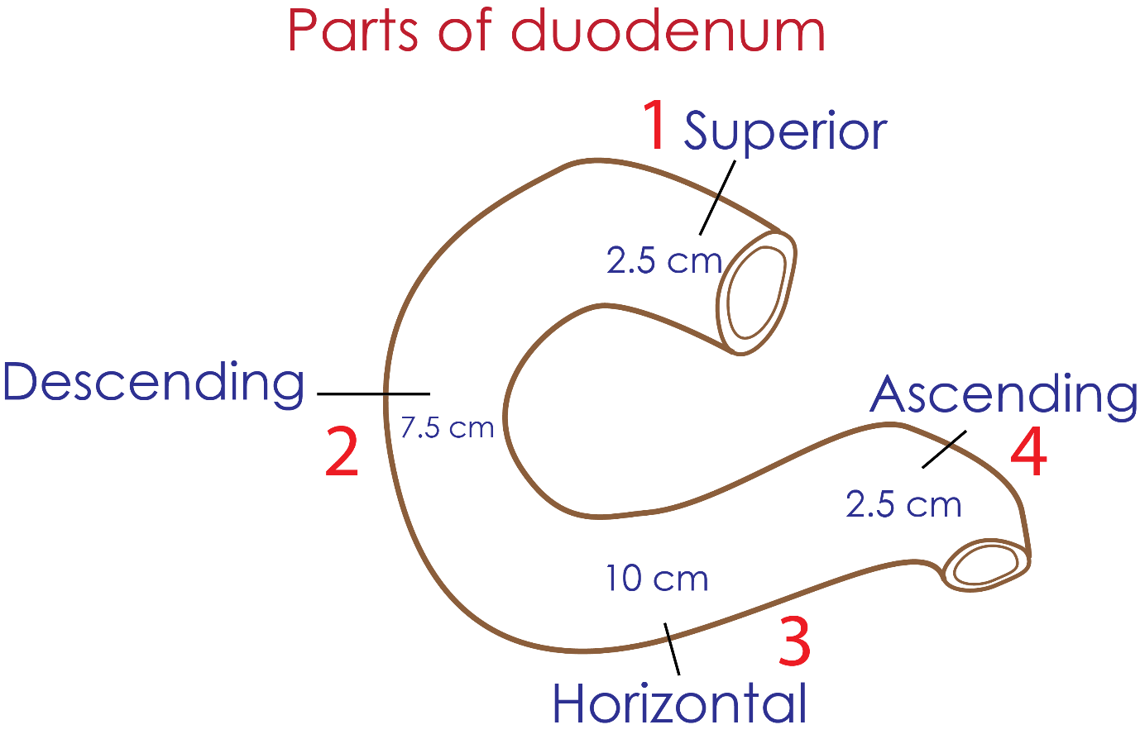

First part of duodenum
= Superior part
2.5 cms
Radiologically - called Duodenal bulb
Attached to hepatoduodenal fold of lesser omentum

At risk relations - posteriorly
First part of duodenum posteriorly is related to
- Gastroduodenal artery
- Common bile duct
- Portl vein
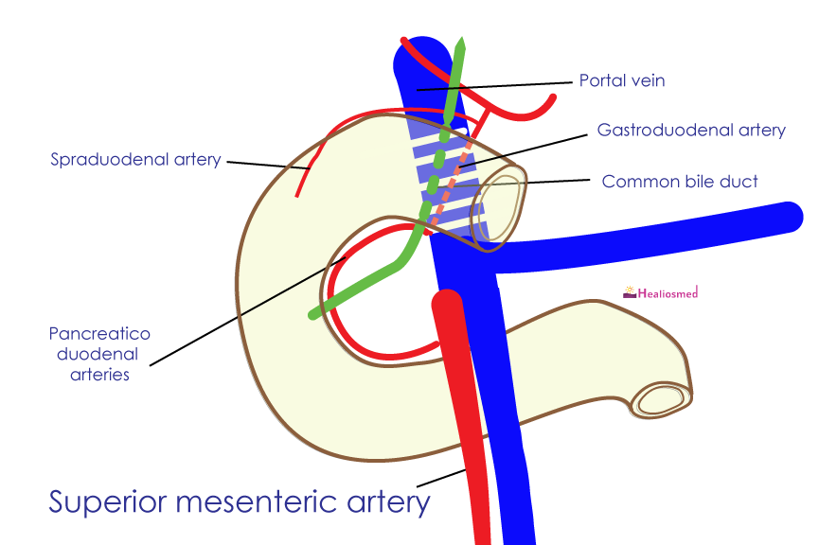

Peptic ulcer
Peptic ulcer eroding the posterior wall of first part of duodenum
Results in significant bleed from gastroduodenal artery

